GLEN ACRES CHURCH HISTORY
-by Ralph Johnson

Albert Ralph Johnson, one of the founding evangelists, was born in 1929, the year of the crash that began the Great Depression, in a little town in Oregon called “Bunker Hill” on a bend in the road going South out of Marshfield, Oregon, later renamed “Coos Bay.” My parents were Edward and Aveline Johnson. I was the first of fourteen surviving children.

After moving around for a few years our family returned to the area and settled just outside Coos Bay, on what we called a “stump ranch,” mostly covered with trees and brush. The way in was through the forest by a road so deeply rutted that one could almost let go of the steering wheel of our old Model T Ford and it would take you home. The house was made of round logs with the cracks between chinked with moss from the swamp. Drinking water was carried up the hill from a spring. Water for other purposes was drawn from a well. There was no electricity. Kerosene lamps provided light. Toilet facilities were a well ventilated out-house with cracks through which you could see whether anyone outside was approaching. The bathroom was a tub placed on the living room floor filled from water heated on the cook stove. And, of course, there was no phone, radio, TV or computer. I learned what God meant by earning your way by the sweat of your brow—chopping wood, making garden, hauling hay and caring for animals.

When I started my formal education in Marshfield, dad took my sister and I to school early in the morning, on his way to work at the sawmill, and dropped us off with the Janitor. Because of this I was held back two years until my sister was old enough to go to school. This actually turned out to my benefit because it gave me an age advantage.

When I was in the fifth grade, a member of the Marshfield Church of Christ, Clarence Oxenrider, began picking us up and bringing us to church. At about 15 I was baptized into Christ and began a fervent study of the Bible. I wanted to be a scientist but became so interested in the Bible that before I graduated I committed my life to training for full-time Christian service. In my last year of high school I commuted to Reedsport, Oregon, to teach a class and helped build the new church building being established there under the leadership of brother Oxenrider.

In 1948 I went to Bible College in San Jose, California, where I met Gene Boulton. Gene was born in 1930 in California, the son of Clarence Boulton, a minister who had served in a number of churches in Northern California. For some unknown reason we clicked right off. In 1950, we went to Coos Bay and worked in the sawmill while we took some training under brother Melvin Traxler. I helped out in the newly established congregation at Bandon, Oregon under the leadership of Don Knowlton.

In the fall we went to Ottumwa, Iowa where we enrolled in Midwestern School of Evangelism under the direction of Donald Hunt, Burton Barber and James McMorrow. I eventually received a Bachelor of Sacred Literature and Bachelor of Theology degrees.

In the fall of 1950, I was asked to minister in Abingdon, Iowa, a few miles east of Ottumwa. There I met and married Helen Nordyke, Dec. 23, 1951. While there a daughter, Barbara, was born, March 22, 1953. My ministry continued there until 1954.

I was ordained as Evangelist at Hamburg Iowa, Church of Christ by Dale Knowles, March 28, 1954 with recommendation of my home congregation, the Coos Bay Oregon Church of Christ.

STARTING THE CHURCH IN SEATTLE

Glen Acres Church began, not as a planned soundly funded program to establish a new congregation with a few dozen well established families in an area, but as a hair-brained venture by a couple of young visionaries who had more zeal than knowledge.

While students at Midwestern School of Evangelism in Ottumwa, Iowa in 1953, the Gene Boulton and Ralph Johnson families rented a house together at 804 E. Holt Street in Ottumwa, Iowa. Gene was married to Bonnie Junker and Ralph was married to Helen Nordyke. Ralph had one daughter, Barbara. This was a time of great dreaming together.

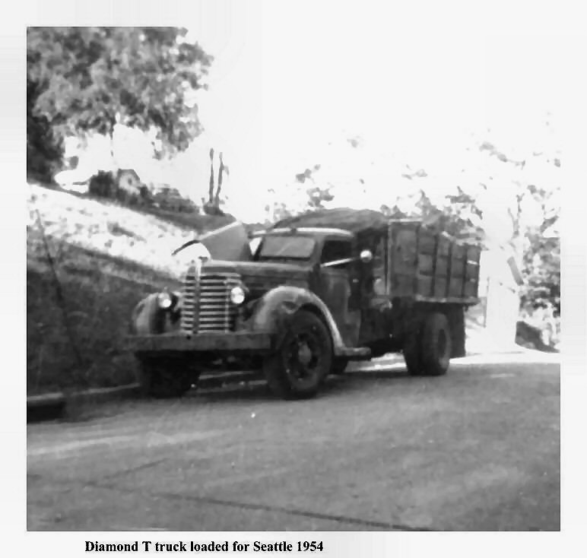
Out of this grew a plan to go to Washington State to start churches. Because Seattle was a major city from which main highways ran north, south, and east, this was chosen as the point of beginning. In 1954 we teamed up with Frank Campbell from the Eugene, Oregon, area, and began preparing for the move. We bought an old 1932 Diamond T truck to haul our belongings and Helen and I, with our daughter, Barbara, began the journey.

It was not exactly the smartest thing we ever did but, as my uncle said later, God seems to have a way of looking out for people like that. What we did not know was that we did not have enough money to complete the trip --much less to get a place to stay and keep us until we could earn something.

We chugged along at 35 miles an hour across the country (lest we blow up the engine). In Idaho we stopped to visit a preacher friend, Chuck Richards, with whom I had gone to school in San Jose. He asked me to preach, and gave us some money. In Helix, Oregon, (near Pendleton) we stopped to see my grandmother, and to my surprise, my uncle was visiting. I asked for nothing but he also gave us money. We did not know it but our trip through Washington was to take almost all of our funds.

In Washington we were charged the commercial rate for moving a truck through. This, and the cost of gasoline and food, brought us to less than five dollars when we arrived in Seattle on an evening in July, 1954. When we arrived, we went to the newly established Puget Sound College of the Bible in West Seattle, which was on summer vacation, and they very kindly let us sleep in one of the rooms. We told them of our plans and asked where we should start a church. They looked a little skeptical but suggested the White Center area. We went there and found Sparkman and McLeen Realty. The son of one of the owners was working while on vacation from college and gave us some special help. Two days later we found a house in the Burien area at 13419 4th Ave. SW for $4,500. How do you buy a house with no money? The bank would not talk to us. The realtor ultimately came up with an arrangement with Singleton Finance in white Center to get us $75 on our truck, of which $50 went to the realtor and the balance to us to live on until I could get a job and earn some money. We later sold the truck to pay off the loan and the down payment on the house.

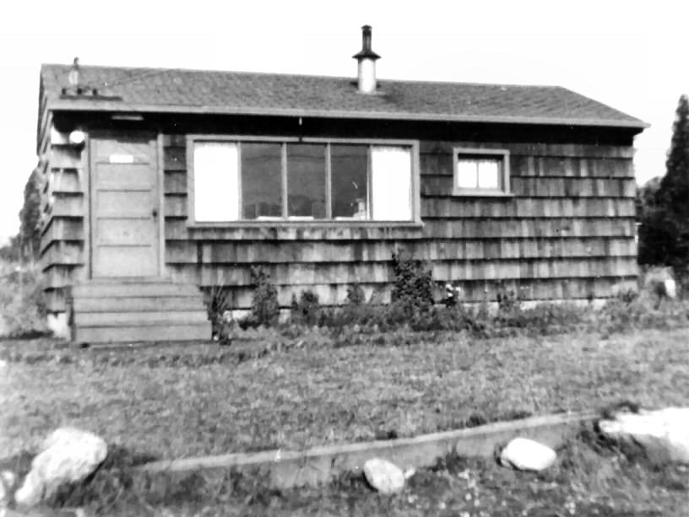
The day we moved in, a paperboy from around the corner, Kenneth Winters, came by to get a subscription to the Seattle Times. We could not afford to at the time but said we would when we could and asked where he lived. He showed us and later, when I wanted to find a job, I went over to get a paper. His parents, Clinton and Virginia, were very helpful. They told me of a part-time job opening at Serv-U-Grocery on the corner of First Ave. South and 136th. I went and begged the job. That got us through until the next summer, when I found a job at Kaiser Gypsum Company, where I worked for the next 9 years.

The Winters mentioned that a couple of Mormon girls were teaching them. They invited me to come and that was the last study they had. The Winters became the first members of our church.

The little house we moved into was only 15 foot wide and 28 foot long. We had no bed, so for the first month the three of us slept on the floor on a baby mattress with pillows on each side. At the end of the month the Winters took us to the St. Vincent De Paul thrift store to buy a bed. We tied it onto the top of the car and started home. When we turned the corner on the street where we could see our house, we saw the car of Gene and Bonnie waiting for us in our driveway. They got the bed and we slept on the floor for the next month until we could afford to buy another one.

Our first few meetings of the church were in our living room. It was about 16 feet long by 8 feet wide. People sitting on the sofa along one wall could almost touch the apple boxes that served as a bookcase along the wall on the other side of the room. We continued meeting there until Frank Campbell arrived and bought a house a couple of blocks north and around the corner. We then fixed up his living room and rented some chairs from a funeral home.
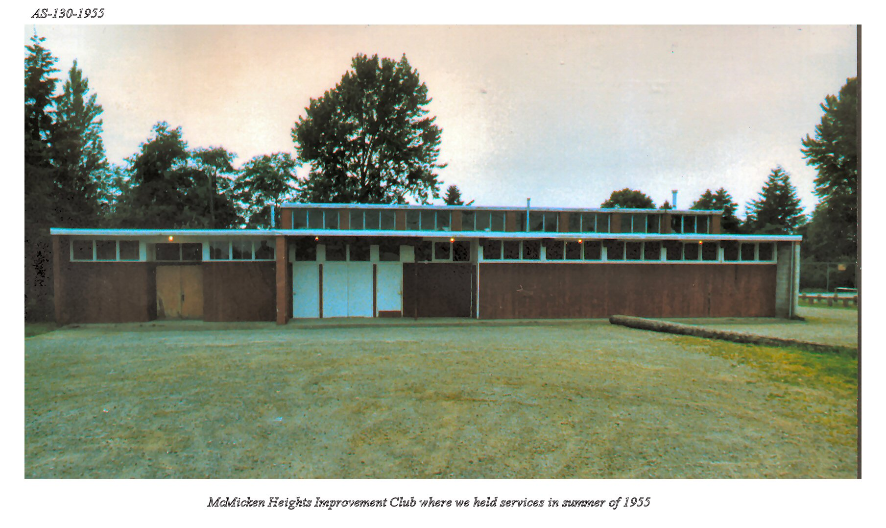
In the summer of 1955 we rented McMicken Heights Improvement club for Sunday services.

OUR FIRST CHURCH BUILDING

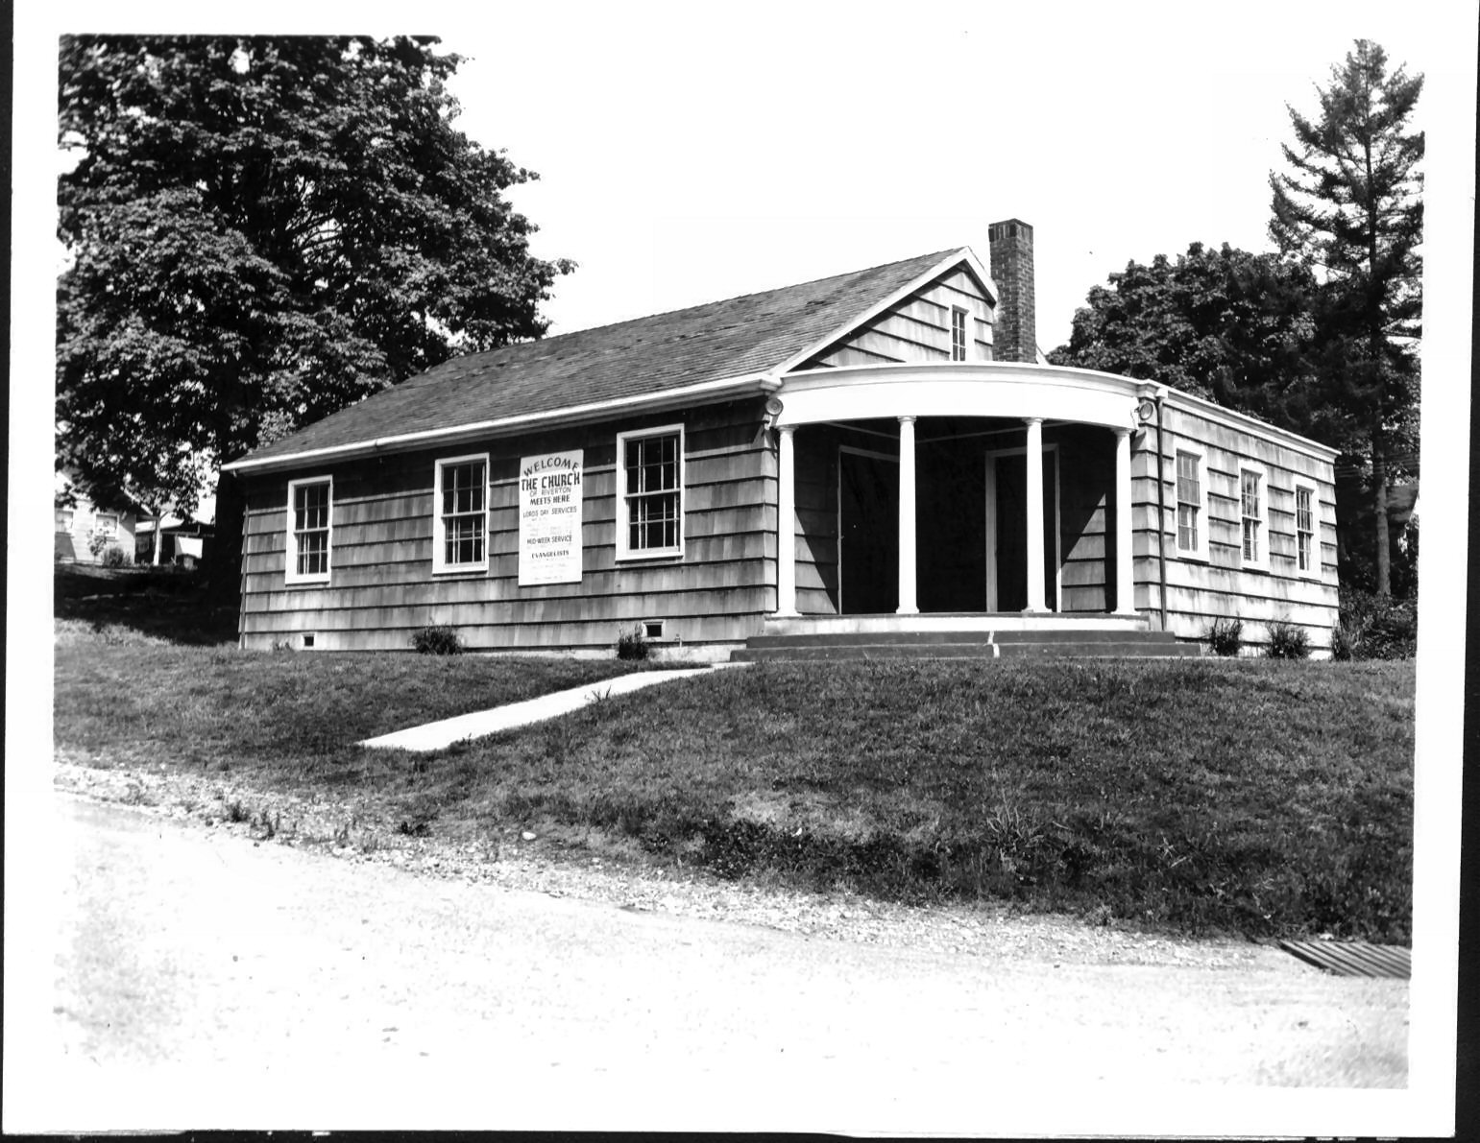
In the fall of 1955 we located a small but very nice church building with knotty cedar board interior at 13045 42nd Ave. S., down in the old Riverton area, just south of the Duamish River. The building was owned by the Christian Science Society of Riverton. They wanted to sell it for $7,000. The only offer they had was from a gun club for less money for cash but they did not want to sell to them. We accepted their price and offered $75 a month with $1,000 down to be raised in three months. They gave us all of their pews, the piano, and the pulpit, which set us up in business. We still have those pews. Later we remodeled and sold our house on 4th Avenue Southwest and purchased the house next door to the church building for the parsonage. This also provided more classroom space.

LEGAL INCORPORATION

On January 8, 1960, we incorporated as the Riverton Church of Christ. By that time, Gene's dad, Clarence Boulton, from California, and Lewis Commons, preacher from Duke Street in Portland, Oregon, had come to help in the work. Gene and Lewis moved to North Seattle to try to start a work, which eventually failed. At Riverton, Clarence built an addition on the building to provide more classrooms and a baptistery.

In 1963 Chuck and Gerry Mitchell came to us. Chuck was originally reared a Mormon. At the time, Chuck worked for Boeing. Gerry started teaching a children’s class.

Darrell Chase and his wife, Carolyn came in 1966 from a non-instrumental Church of Christ. Darrell was an engineer who had moved to Seattle from Richland, Washington to work for Boeing. Carolyn's father, Kenneth Edwards, was a well-known preacher in the Northwest and teacher at North West College of the Bible in Portland, Oregon. Her uncle, Gordon Thompson, was a missionary to Puerto Rico and the Dominican Republic. Darrell became a teacher of the young people's class shortly after coming to Riverton. He became a deacon in December, 1968. Carolyn was a school teacher and taught in our Bible School program.

BEGINNING FULL TIME MINISTRY

September 1, 1967, Ralph was put on full time ministry. His family had grown to four children, two boys and two girls, Barbara, David, Janet and James.

WESTSIDE CHURCH (LATER, CROWN HILL) BEGINS

September, 1970, the Riverton Church had grown to where we decided to start another congregation. A building at 6740 16th Ave. SW was purchased to begin the Westside Church and Myron Wells, son of Evangelist, Claude Wells, was called to take the leadership. His wife was Donna, daughter of Evangelist, Don Jessup.

CHURCH CAMP

In August of 1974, Riverton Church participated with other churches in Washington in starting Dudley Christian Camp at the YMCA camp on Clear Lake in White Pass near Nachese, Washington for young people from the fourth grade through High School.

THE GLEN ACRES CHURCH BUILDING

September of 1975, the Riverton Church had grown to where we needed a larger building. The present building at 11401 10th Ave. S was leased from the Highline School District and we became known as, Glen Acres Church of Christ. It had been built as a Lutheran church and later sold to the school district. It has about four acres of land. The Johnson family moved into the kitchen and rooms in the West wing. Three years later the property was purchased from the district for $97,000.

THE PARSONAGE

September, 1976, the parsonage next door at 11435 14th Ave. S. was purchased for use of the Johnsons.

SEATTLE CHRISTIAN COLLEGE BEGINS

September, 1978, Seattle Christian College was begun under the cooperative leadership of Lee Turner, who had moved to North Seattle from a missionary work in Pakistan, Myron Wells, and Ralph Johnson. The facilities of the churches were used for classes.

KENT HILL CHURCH (CEDAR RIDGE) BEGINS

September of 1978, the Kent Hill church, formed from a large group of people from Glen Acres, began meeting under the leadership of Don Fleming. It grew rapidly and in a few years reached an attendance of around two hundred.

The same year, Myron Wells left the Westside Church to take leadership of the North Central church in Spokane, and Bill Paul was called from Denver, Colorado, where he was preaching and teaching to lead the West Church. Bill had been instrumental in founding three Bible colleges and was valuable in filling Myron's place in our school. Under Bill's leadership the congregation was moved to Crown Hill in North Seattle. Families from Glen Acres that lived in the north end were encouraged to attend there. The congregation eventually reached an attendance of around two hundred. Loss of people from both the North and South slowed the growth at Glen Acres for several years.

GOOD SHEPHARD DAYCARE OUTREACH BEGINS

September, 1980, Good Shepherd daycare was begun under the direction of Shirley Nisley, as an outreach of the church through service to the community.

ORDINATION OF ELDERS

May 1, 1983, Chuck Mitchell, Darrell Chase and Ralph Johnson were ordained Elders. In 2003, Bob Wrubleski also became an Elder. He moved to Spokane, Washington in 2005.

PROGRAMS THE CHURCH HAS SHARED IN FOUNDING OR IN WHICH WE HAVE PARTICIPATED.

Dudley Christian Camp began in 1974. In 2003 it was moved to Grace Brethren camp across the lake and the name changed to Clear Lake Christian Camp.

New Life Northwest family camp began in July 24-28, 1989. Ralph Johnson served as director for several years.

In 1971 we started a music group we called Philadelphia Road and a Coffee House held in the West Seattle Housing Project and also at Centralia and later at Glen Acres. A younger music group, at first called, “One Way” and later “Dayspring” also played.

For several years we had men’s breakfasts once a month, which in 1981 became Good News Ambassadors Toastmasters club.

Seattle Youth Rally started with rallies at Riverton and in 1982 became a joint effort between the three Seattle area churches. It grew so large that in 1987 we had to rent camp Berachah and continues today.

Ralph Johnson hosted an Ex-Jehovah’s Witness Ministry for many years and still speaks on the Northwest Bible Conference. Through contacts from that he has traveled to Canada, Washington D.C., Japan, Korea and other places.

Longview Church, started by Ken Holsinger, was later sponsored by Glen Acres under Eugene Boulton.

Yakima Fertile Valley Church was a cooperative effort of Washington churches.

Valley Church in Spokane was also assisted by the Washington Church planting churches.

Peninsula Christian Church was assisted for several years by Ralph Johnson

Young Christian Adults Retreat (YCAR) began in the fall of 2003 and lasted a few years.

